Please complete all information. |  |  | DISTRICT PERMIT NO.:
Well Owner: | Property Owner: |  | Name of Business/Residence at Site:
Well Owner’s Mailing Address: | Property Owner’s Mailing Address: |  | Address of Well Site:
City, State, Zip | City, State, Zip |  | City, State, Zip
Telephone No.: | Telephone No.: |  | Assessor’s Parcel No. of Well Site:
 |  |  | Book |  |  | Page |  | Parcel
Well on District property/easement (See General Condition E.)
Consultant: |  | Drilling Company:
Address: |  | Address:
City, State, Zip |  | City, State, Zip
Telephone No.: |  | Telephone No.: |  |  | C-57 License No.:
Check if address or phone number has changed |  | Check if address or phone number has changed
All questions below are to be completed before permit can be issued; if unknown, applicant shall make on-site investigation to determine correct answers.
WELL INFORMATION
Well Registration No.: |  |  |  | Owner/Consultant Well No.: |  |  |  | Original Well Construction Permit No.:
Well Casing Depth: |  |  |  | Total Boring Depth: |  |  |  | Well Casing Diameter:
This Section to Be Completed for All Monitoring Wells or Extraction/Recovery Wells
Case Name/No.: |  |  |  |  |  | Caseworker Name:
Oversight Agency: |  |  |  |  |  | Caseworker Telephone No.:
WELL TYPE/USE
 | Water  Production | Monitoring | Remediation |  | Dewatering |  | Heat  Exchange | Injection | Cathodic  Protection | Other
 | Agricultural  Domestic  Industrial  Municipal | GW Level  GW Quality  Inclinometer  Vapor  Other | Air Sparge  GW Extraction  Material Emplacement  Vapor Extraction  Other |  | Permanent  Temporary |  | Closed Loop  Open Loop | Groundwater Cleanup Reinjection  Stormwater  Water Supply Recharge  Other
IMPORTANT: A minimum 24-hour notice must be given to Santa Clara Valley Water District prior to installing the annular seal. Call (408) 630-2660. Please allow 10 working days to process permit application.

SITE PLAN
Well Location  (Draw accurately; recommend using assessor’s map): | EXAMPLE: | 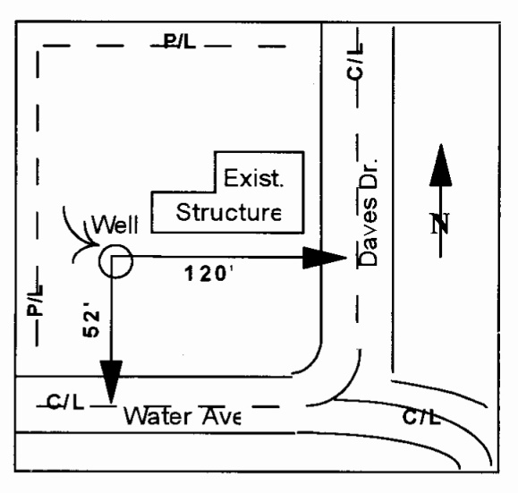
- Sketch well location to scale; show dimensions to nearest foot.
- Show a minimum of two dimensions at right angles. Dimensions shall be from the centerline of the closest named streets, roads, or highways.
Sketch well location as described above:

Please allow 10 working days to process this application.

Please describe in detail the proposed reconstruction method:
SIGNATURES
I understand and agree that all work associated with this permit is required to be done in accordance with Santa Clara Valley Water District (District) Well Ordinance 90-1, the District Well Standards, and conditions of this permit (see page 4). I certify that the information given in this permit is correct to the best of my knowledge and that the signature below, whether original, electronic, or photocopied, is authorized and valid, and is affixed with the intent to be enforceable. I also certify that a right of entry/encroachment agreement has been formalized between the well owner and property owner, if parties differ.
Signature of Well Owner/Agent: |  |  | Print Name: |  | Date:
Signature of Property Owner/Agent: |  |  | Print Name: |  | Date:
Signature of Driller/Agent: |  |  | Print Name: |  | Date:
Signature of Consultant/Agent (if any): |  |  | Print Name: |  | Date:
DISTRICT USE ONLY
Special Conditions:
Permit Approved by: |  |  |  |  | Date:
District Permit No.: |  | Date Issued: | Expiration Date: | Driller’s Log No.:
Please allow 10 working days to process this application.

GENERAL CONDITIONS
- District (telephone 408-630-2660) must be notified a minimum of one working day before the well reconstruction activities. An authorized District representative must be on site to witness the reconstruction activities. This requirement may be waived by an authorized District representative. If the District waives the inspection requirement, the District may request the permittee(s) to furnish certification under penalty of perjury that the well was reconstructed in accordance with the District Well Standards and with the permit conditions.
- This permit is valid only for the purpose specified herein. Well reconstruction methods authorized under this permit may not be changed except by written approval of an authorized District representative, and only if the District believes that such a change will result in equal or superior compliance with the District and State Well Standards (e.g., if the District representative believes that site conditions warrant such a change).
- This permit is only valid for the Assessor’s Parcel No. indicated on it.
- If any work associated with this permit will take place on District property/easement, an encroachment or construction permit must be granted by the District’s Community Projects Review Unit (telephone 408-630-2350, -2217, or -2253).
- Within 30 days of the completion of the well reconstruction activities, the driller identified on this permit shall fully complete State of California DWR Form 188 and submit the original to the District’s Well Ordinance Program.
- The permittee(s) shall assume entire responsibility for all activities and uses under this permit and shall indemnify, defend, and hold the District, its officers, agents, and employees free and harmless from any and all expense, cost, and liability in connection with or resulting from, the granting of or exercise of this permit including, but not limited to, property damage, personal injury, and wrongful death.
- Permittees are required to be in full compliance with Cal/OSHA California Labor Code Section 6300.
- A current C-57 Water Well Drilling Contractor’s License is required for the reconstruction of all wells.
- Permittee, permittee’s contractors, consultants, or agents shall be responsible to assure that all materials generated during drilling, well destruction, well development, pump testing, or other activities associated with this permit will be safely handled, properly managed, and disposed of according to all applicable federal, state, and local statutes regulating such. In no case shall these materials/waters be allowed to enter, or potentially enter, on- or off-site storm sewers, dry wells, or waterways. Such materials/waters shall not be allowed to move off the property where the work is being completed.
- The driller and consultants (if applicable) shall have an active copy of their Worker’s Compensation Insurance on file with the District.
- This permit shall expire if not exercised within 180 calendar days of its approval unless an extension of the permit expiration date is granted by an authorized District representative.
- This permit must be kept on site during all activities associated with it and shall immediately be presented to an authorized District representative upon request.
- Permittee shall notify Underground Service Alert (USA) at 1-800-227-2600 or 811 prior to any digging.
Please allow 10 working days to process this application.

