TO BE COMPLETED BY VALLEY WATER
Valley Water Permit No.: | Date Issued: | Expiration Date:

TO BE COMPLETED BY OWNER AND CONTRACTOR/CONSULTANT
Property Owner: | Well Owner (If different): |  | Name of Business/Residence at Well Site:
Property Owner Address: | Well Owner Address: |  | Address of Well Site:
City, State, Zip: | City, State, Zip: |  | City, State, Zip:
Telephone No.: | Telephone No.: |  | Assessor’s Parcel No. of Well Site:
 |  |  | Book |  | Page |  | Parcel
Contractor/Consultant Company Name:

Address: |  | Telephone No.:
City, State, Zip: |  | License No.:
All questions below are to be completed before permit can be issued; if unknown, applicant shall make necessary on-site investigation to determine correct answers.
WELL INFORMATION
Previous/Standby Permit No. (If any): | Date of Last Use: |  |  | Well Registration No.:
Owner/Consultant’s Well No. (If any): | Date of Planned Well Reactivation: |  |  | Original Construction Permit No. (If any):
Depth of Well: | Diameter of Casing: |  |  | Type of Casing (Steel, PVC, etc.):
Reason for Placing Well on Standby Status:

Well Location  (Draw accurately; recommend using assessor’s map): |  | EXAMPLE: | 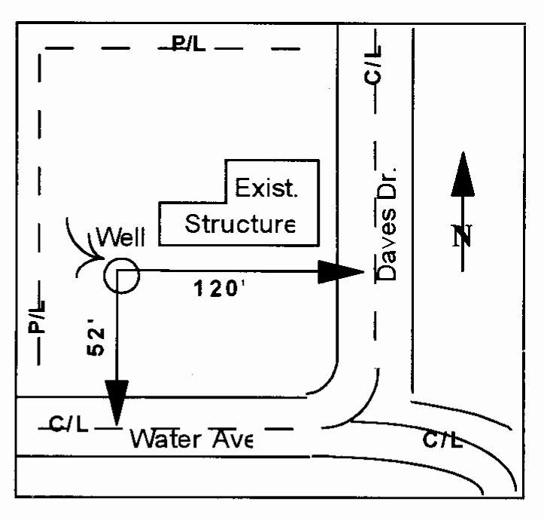  New  Well
- Sketch well location to scale; show dimensions to nearest foot.
- Show a minimum of two dimensions at right angles. Dimensions shall be from the centerline of the closest named streets, roads, or highways.
- Show location of existing wells.
Please sketch well location below:

r

OWNERS STATEMENT
I agree to properly maintain the well described in this permit so that:
1. The well and associated piping has no surface defects which may impair quality of water in the well or in the water-bearing formations penetrated.
2. The well head is watertight and appropriately protected to prevent the entrance of undesirable water or foreign matter.
3. The well head is watertight and appropriately protected to prevent the uncontrolled flow of water from the well.
4. The area around the well is kept clear of brush or debris.
5. There are no cracks, voids, or defects in the well pad.
I also agree:
6. To complete a Well Reactivation Notice and send it to Valley Water’s Well Ordinance Program within 30 days if the well is reactivated.
7. To obtain a Well Destruction Permit from Valley Water’s Well Ordinance Program, call (408) 630-2660, if the well is to be destroyed.
8. To comply with the general conditions on the last page of this permit.
Property Owner Signature: | Print Name: | Date:
Well Owner Signature (If different): | Print Name: | Date:

CONSULTANT/DRILLER/PUMP CONTRACTOR’S CERTIFICATION STATEMENT
1. The well and associated piping has no surface defects which may impair the quality of water in the well or in the water-bearing formations penetrated.
2. The well head is watertight and appropriately protected to prevent the entrance of undesirable water or foreign matter.
3. The well head is watertight and appropriately protected to prevent the uncontrolled flow of water from the well.
4. The area around the well is kept clear of brush or debris.
5. The well has a pad and the pad has no cracks, voids, or defects.
6. The well is capable of being used for its intended purpose. Please briefly explain how this was determined (i.e., pump test, sounding well, video camera, etc.):
Driller/Pump Contractor Signature: |  | Print Name: | License No.: | Date:
Consultant Signature (R.C.E., E.G., or P.G. req’d): |  | Print Name: | License No.: | Date:

TO BE COMPLETED BY VALLEY WATER
Inspector: | Comments:
Date:

GENERAL CONDITIONS
A. Permit automatically expires after a period of two years. Well owner is responsible for obtaining a new permit every two years if the well continues to remain inactive.
B. Permittee must comply with all of the provisions of Valley Water’s Ordinance 90-1, the “Standards for the Construction and Destruction of Wells and other Deep Excavations in Santa Clara County,” the California Well Standards, and subsequent supplements and revisions, if any.
C. This permit is valid only for the purpose specified herein. No change in inactive well procedures as prescribed by Valley Water will be allowed except upon written permission by Valley Water.
D. Permittee shall assume entire responsibility for all activities and uses under this Permit and shall indemnify, defend, and save Valley Water, its Officers, agents, and employees free and harmless from any and all expense, cost, or liability in connection with or resulting from the exercise of this Permit including, but not limited to, property damage, personal injury, and wrongful death.
E. Compliance with “CAL/OSHA,” California Labor Code Section 6300 (and following) is required.
F. Water quality and production from all wells to be used for public water supply must be approved by the County Environmental Health Services.
G. Each well requires a separate standby well permit.
H. The inspection of the inactive/standby well must be conducted by a driller with a vaild C-57 or C-61 license, or a consulting firm with a responsible professional (registered civil engineer, certified engineering geologist, or professional geologist).
I. An authorized Valley Water representative must be on site to witness the contractor’s/responsible professional’s inspection of the well. This requirement may be waived by an authorized Valley Water representative. Valley Water’s Well Ordinance Program must be notified (408-630-2660) a minimum of 24 hours prior to the contractor’s/responsible professional’s inspection.

Permit Approved by |  | Title |  | Date

