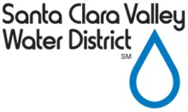 | REQUEST TO SPEAK  FC 244 (09-06-17)
This document is a public record, subject to disclosure under the California Public Records Act.
If you would like to submit your comments anonymously, you may leave the speaker information section blank.
- Please fill out a separate Request to Speak form for EACH item you would like to comment on.
Meeting Date: |  |  | Agenda Item Number: | For  Against  Neutral
Speaker Information Section (please print clearly):
Name:
Organization:
Address:
Phone:
E-mail:
If you want to provide written comments only, and do not wish to address the Board or Committee orally, please write your comments below:

